Lesson 1: What is Pygame?
Pygame is a Python library used to create 2D games.
Space Shooter

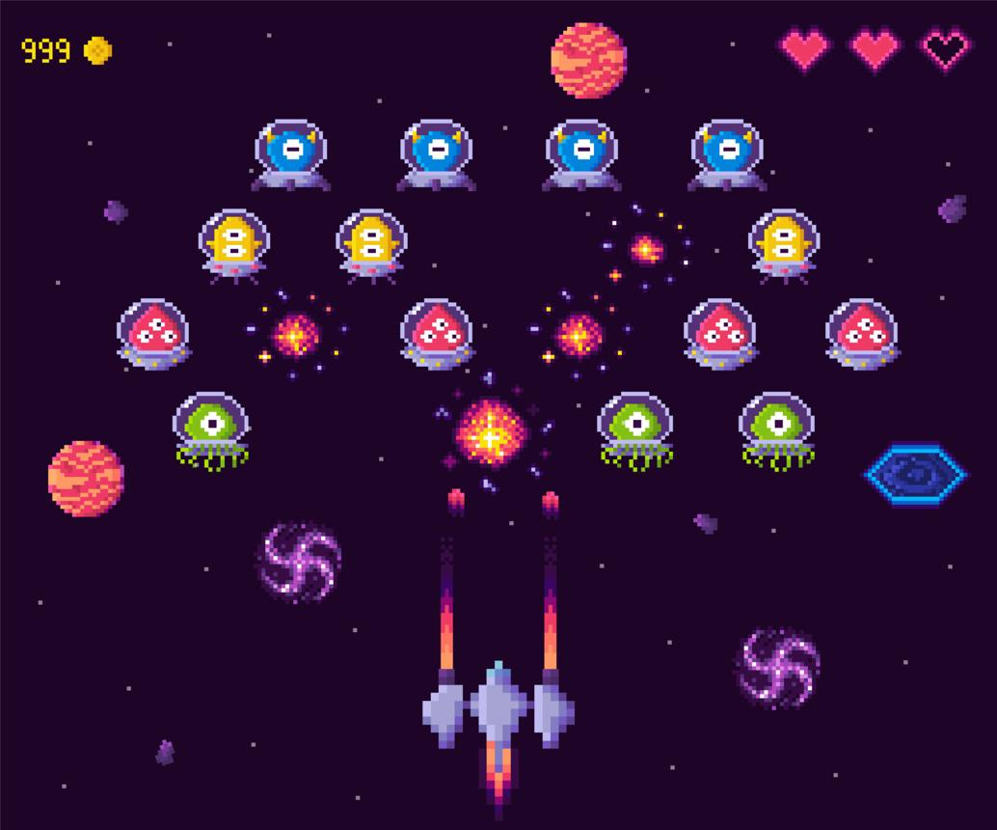
With Pygame, you can create:
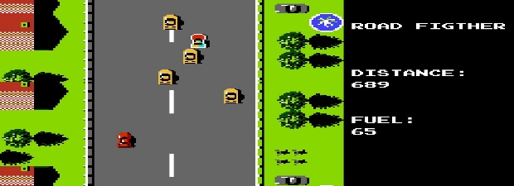
Car Racing

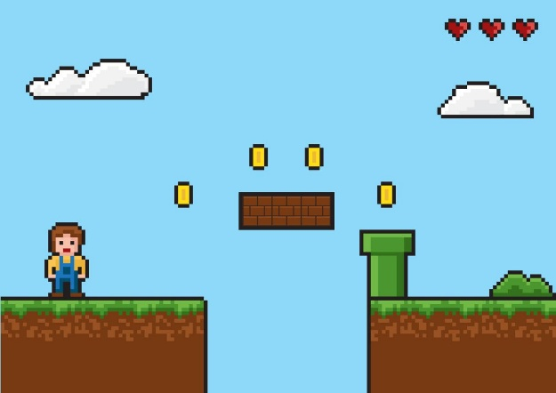

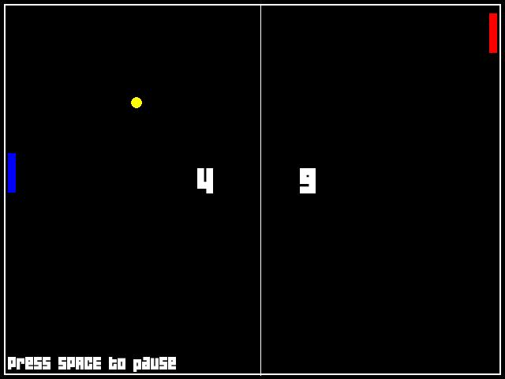
Platformer

Step 1: Install Pygame
Open your terminal or Command Prompt and type:
pip install pygame

Step 2: Create your first game window
Create a Python file named lesson1.py and write this code:
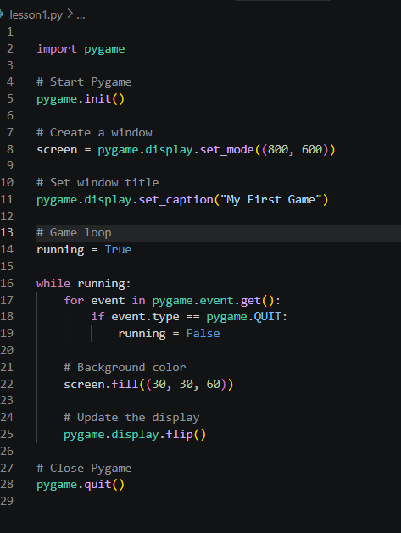

Run it:
python lesson1.py
Congratulations! 🎉 You have created your first game window.

Step 3: Understand the code
Let's understand the important lines.
Code | Simple meaning
import pygame | Bring Pygame into our program.
pygame.init() | Start the Pygame modules.
set_mode((800, 600)) | Create a window 800 pixels wide and 600 pixels high.
set_caption() | Give the window a title.
while running: | Keep the game running.
pygame.event.get() | Check events like key presses and closing the window.
screen.fill() | Paint the background.
pygame.display.flip() | Show the latest drawing on the screen.
pygame.quit() | Close Pygame properly.

What is a game loop?
A game loop is a block of code that runs again and again while the game is active.
For example:
- Check what the player does.
- Move the player.
- Draw the game.
- Repeat!
Without a game loop, your game cannot continuously respond to the player.

Step 4: Change the background color
Find this line:
screen.fill((30, 30, 60))
Change it to:
screen.fill((0, 150, 0))
Run the game again. Your background will become green.
Colors in Pygame use RGB values:
- Red: (255, 0, 0)
- Green: (0, 255, 0)
- Blue: (0, 0, 255)
- White: (255, 255, 255)
- Black: (0, 0, 0)
Each value ranges from 0 to 255.

Step 5: Your first practical challenge

Pygame Challenge
Change your program to complete these tasks:
Make the background red.
Change the window size to 1000 × 700.
Change the window title to My Racing Game.

